w

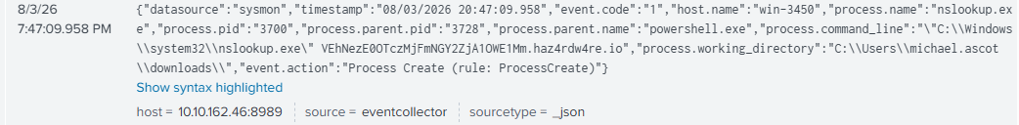

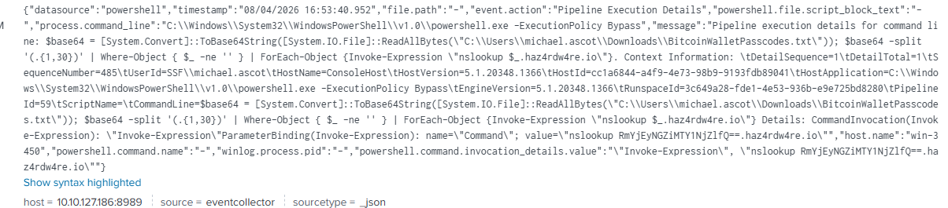

On 8/3/26 host.name 3450 (Michael Ascot), someone at this host machine clicked on a link which opened powershell and executed a nslookup which allowed

At the same time we can see that Mr. Ascot’s terminal accessed bitcoinWalletPasscodes.txt and it appears that it is being spread with the same haz4rdw4re.io and will appear to have come from Mr. Ascots computer (win-3450)

Nslookups; RmYjEyNGZiMTY1NjZlfQ ==.haz4rdw4re.io and VEhNezE0OTczMjFmNGY2ZjA1OWE1Mm ==.haz4dw4re.io

Another attack on mr. ascot

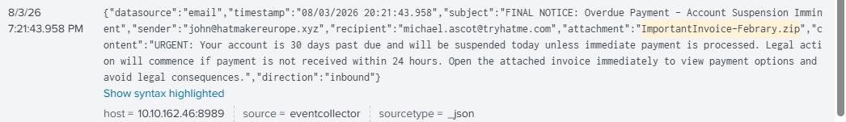

7/21 email from hatmakereurope.xyz had attachment that looked like an official invoice .zip file, ImportantInvoiceFebrary.zip (notice that February is misspelled. 1st clue).

At 7:42 Sysmon reported information that shows that this invoice actually held a hidden file, invoice.pdf.lmk and shows that the process name was explorer.exe and that a “File stream created”

Also changed pathnames several times. 1 example below:

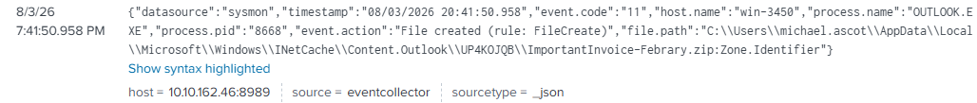

Launching the invoice.pdf.lmk opened powershell and created a reverse shell using powercat.cs1
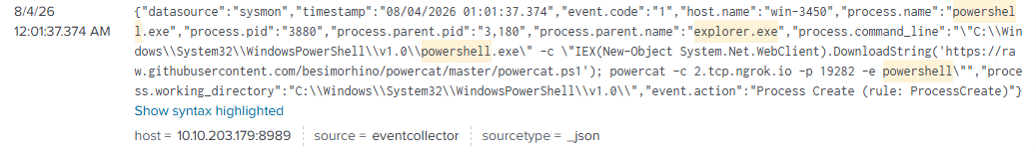

IEX in a file name indicates that (per google)

- 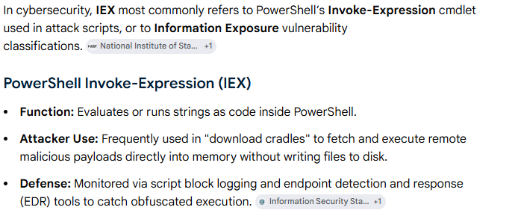
Images indicating that he was working on an important invoice prior to clicking the malicious link

